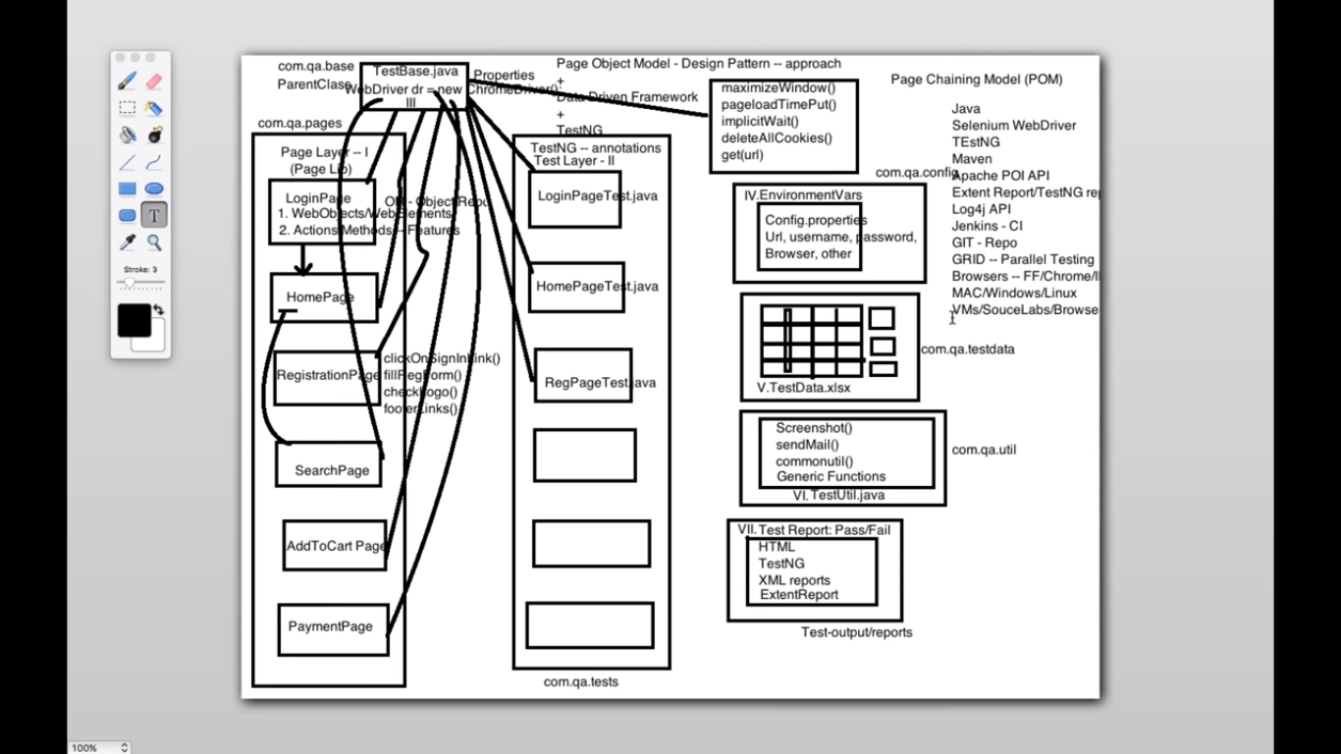

I haven’t used Media Pulse but I have experience in the following:

MPX for video content management from Comcast:

* It offers end-to-end and modular solutions
* It has advanced workflow and distribution
* Asset Management
* Easy Media publishing to TV’s, Mobile devices and PC’s.

Reporting, exception handling, logging, data reading, and writing components are the main aspects. I also used Page Object model to have object repository and single code base.  
I developed the framework in level, so that different components can be used in automating multiple application. For this purpose, I designed the Reporting component using the ITestListeners and ISuiteListeners of the TestNg. For logging and debugging purposes used the Log4J library. Apart from that a exception class was developed and used for handling the different types of exception that may occur in browser and mobile based application. This component also utilized the abstraction principle of Java Object Oriented principles, so that more narrow exceptions can be defined in the child classes extending this.   
I created a session sharing and switching component so that test cases can be loaded to both mobile and desktop browsers by changing the context.  Data providers were used for Data driven testing using TestNg Data providers. A runner class that binds the data and the test cases to run priority based testing. Also developed Page Objects using Page object model and UIAutomatorViewer.Used Maven and POM.xml to load the dependencies of the project.

this is some sample